2000031668

K Lohith

SEC-13 SKILL-9

POST DETAILS of EMPLOYEE

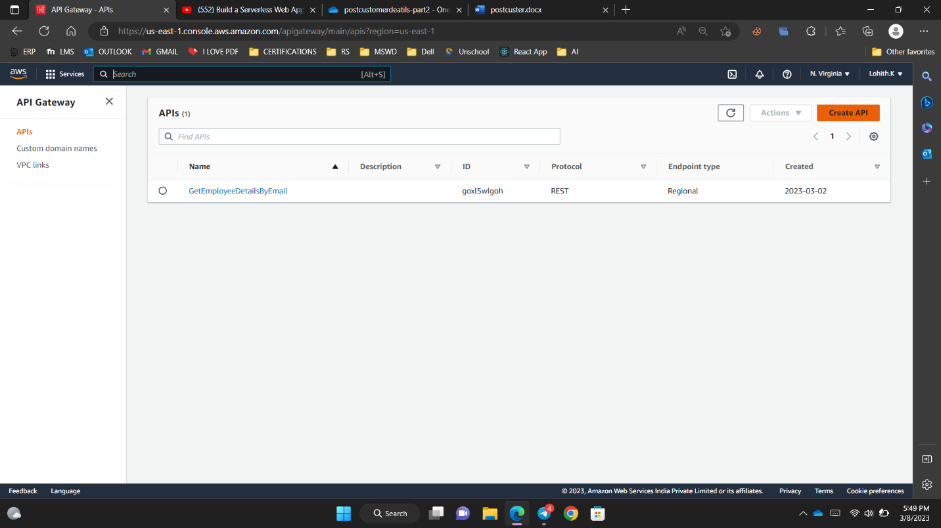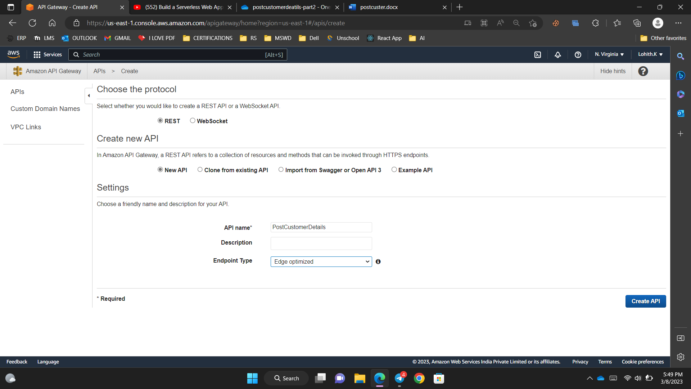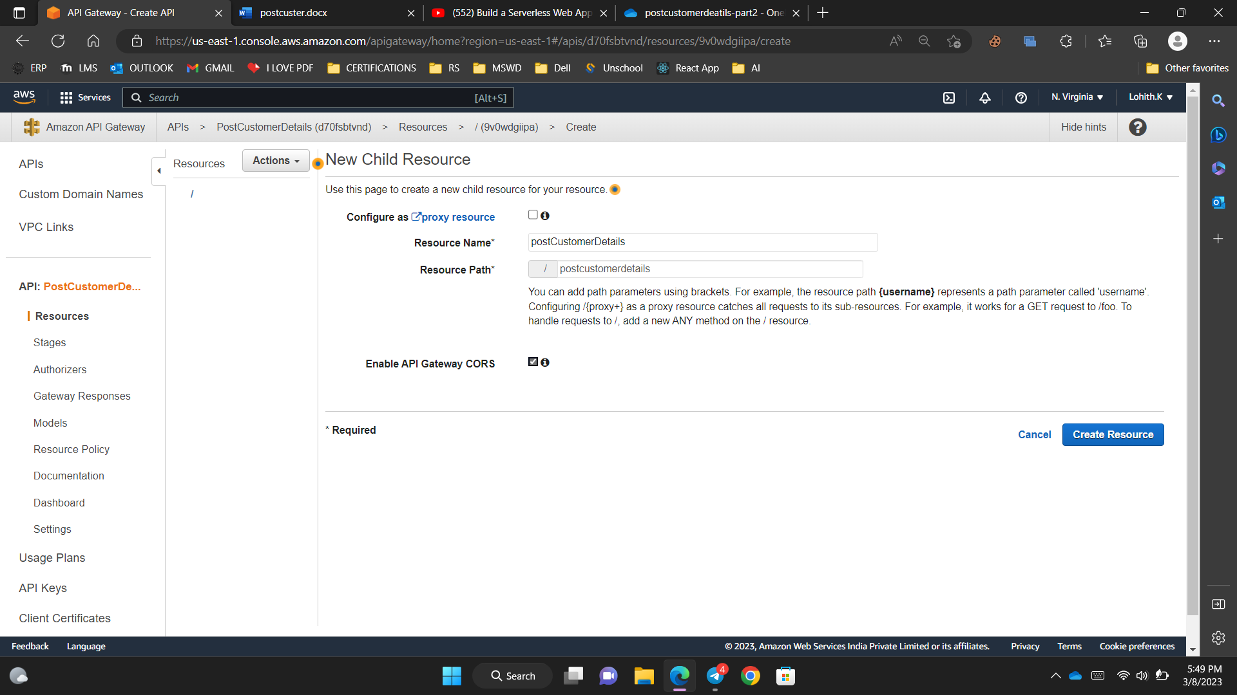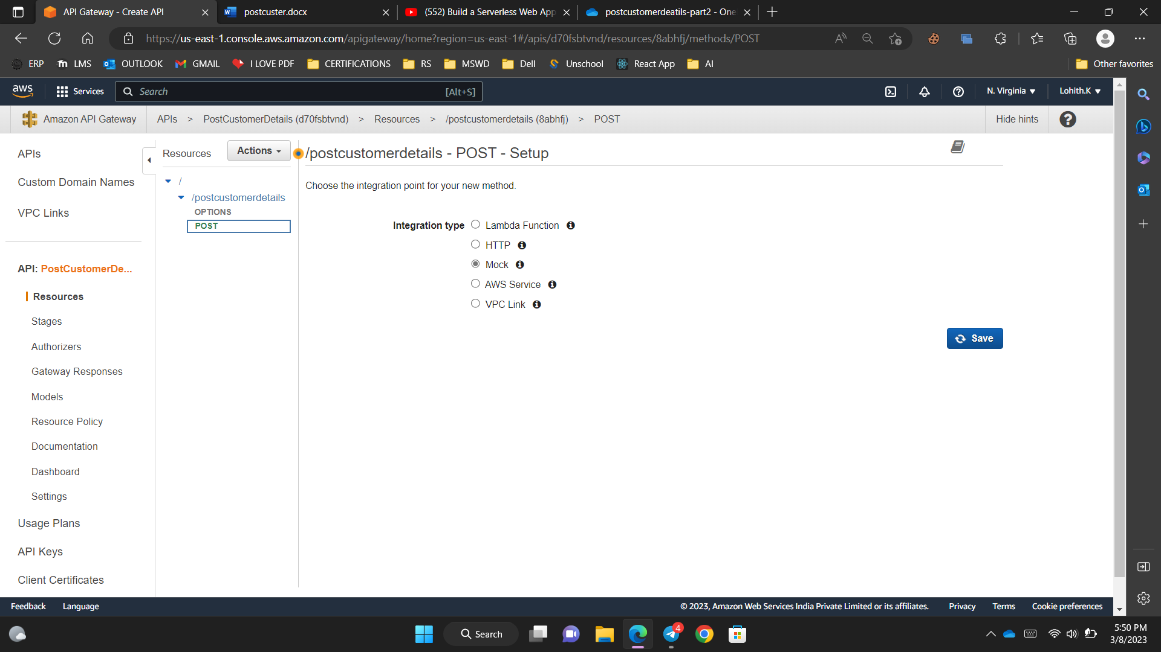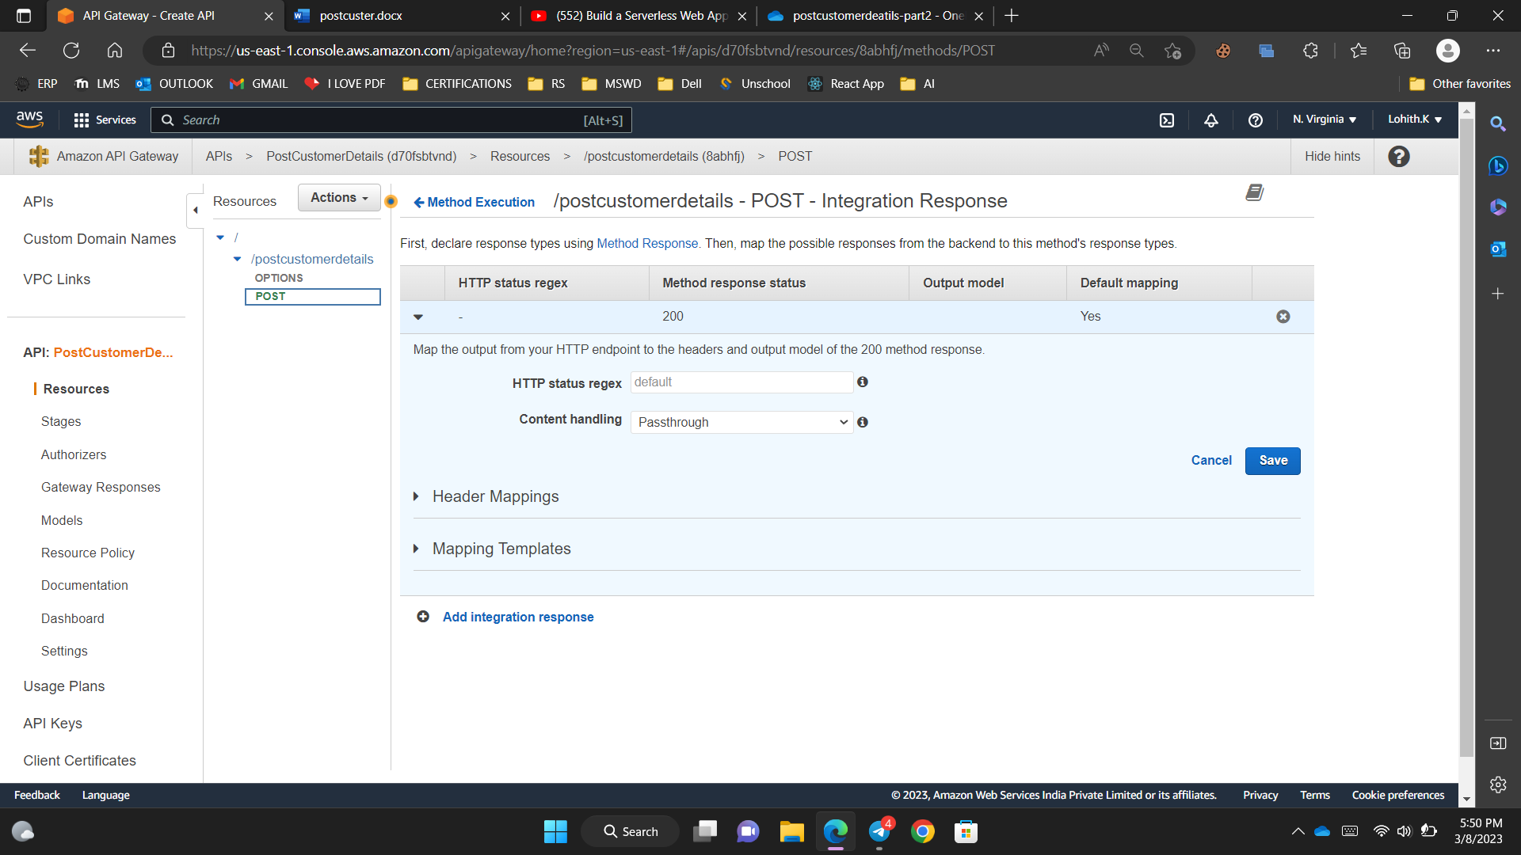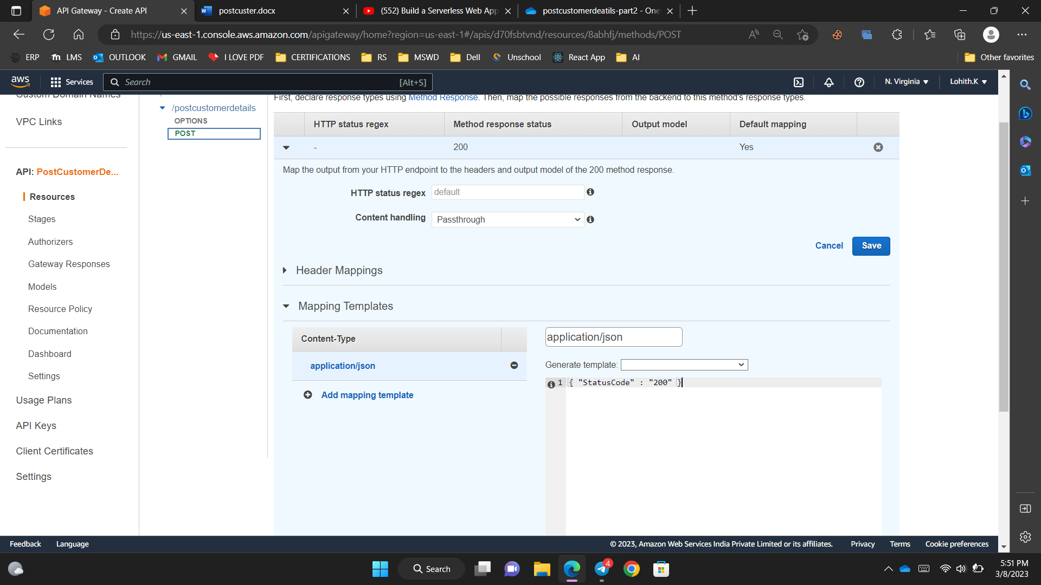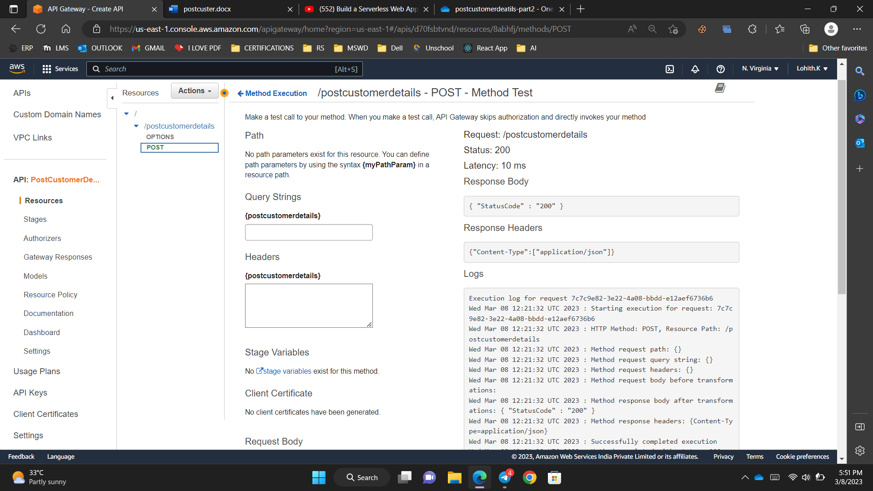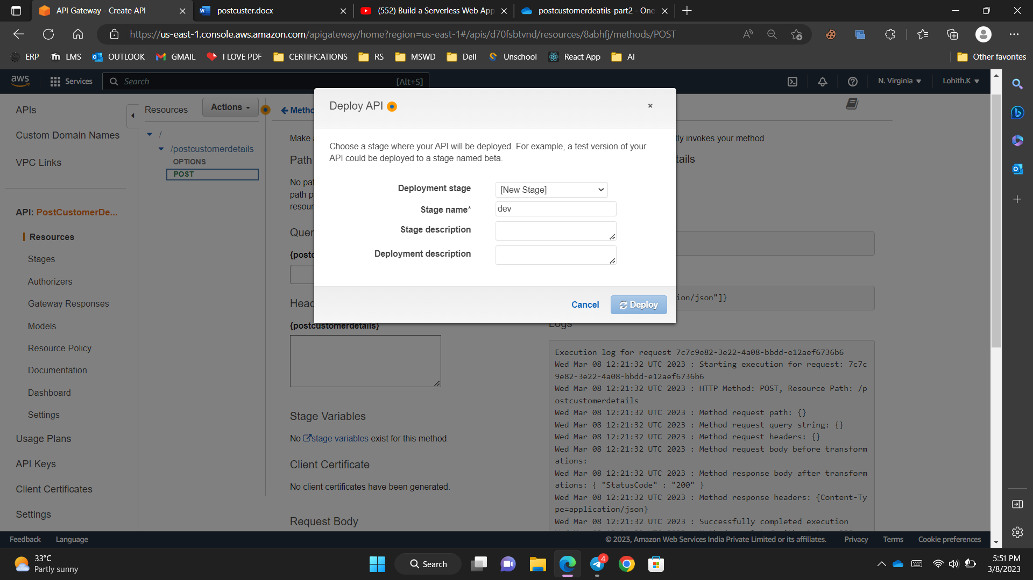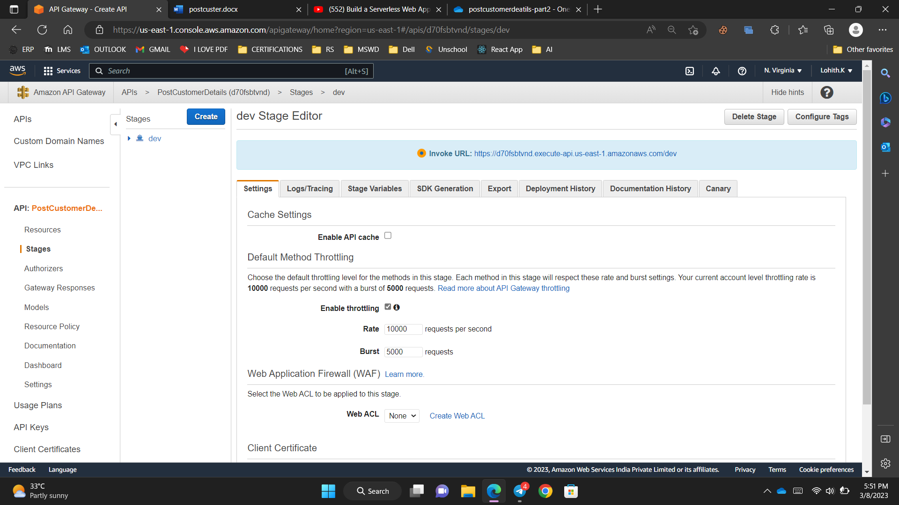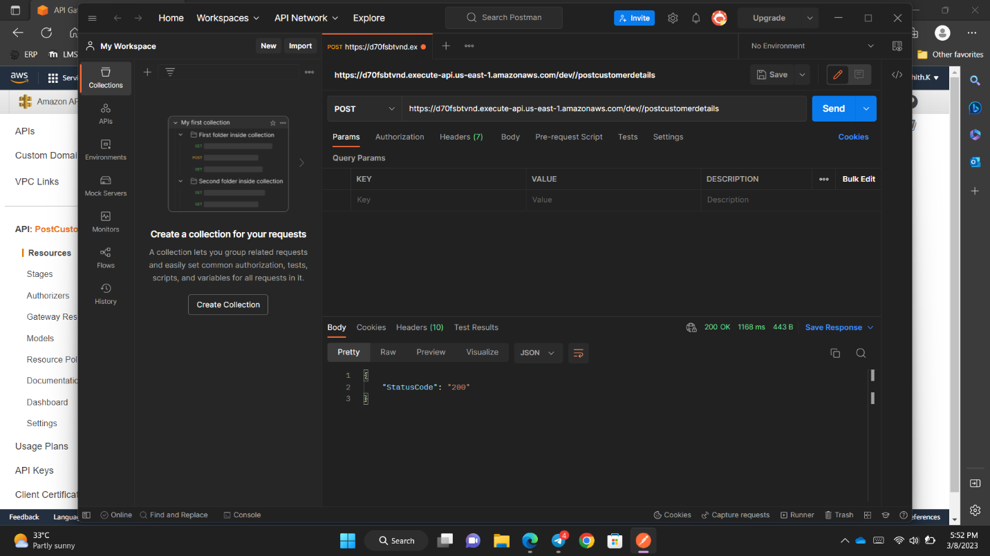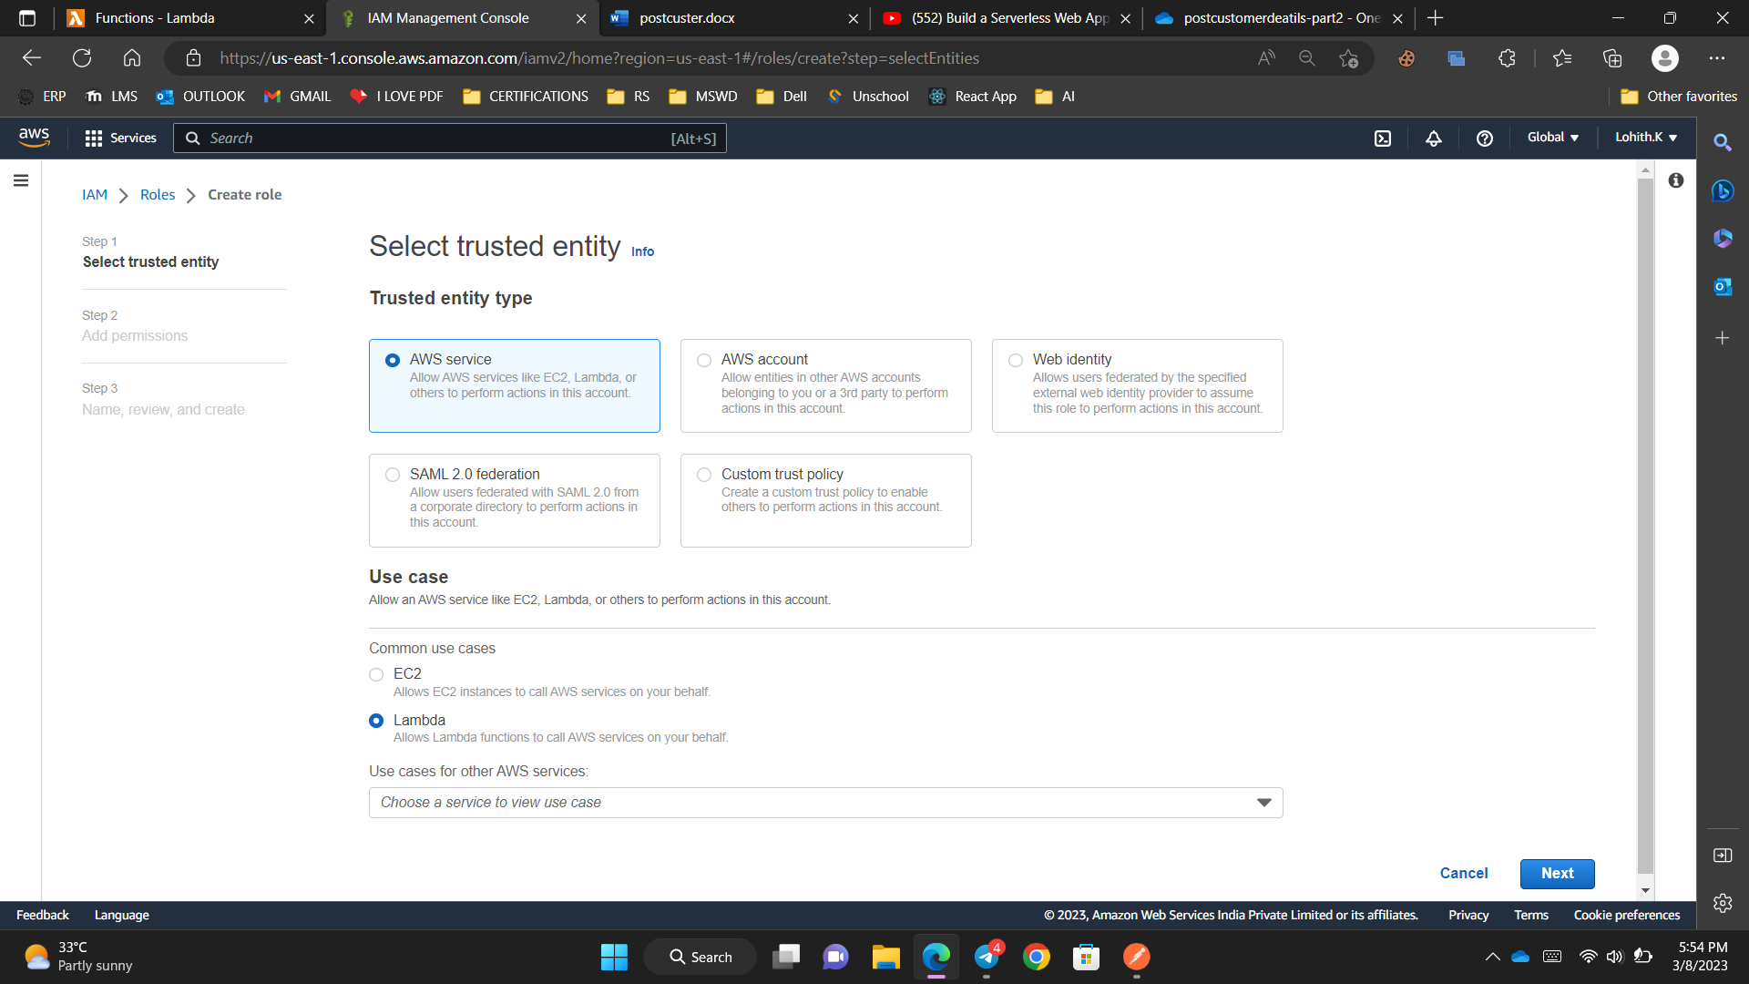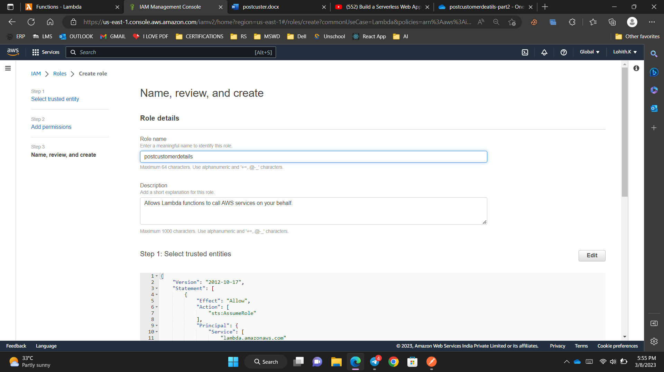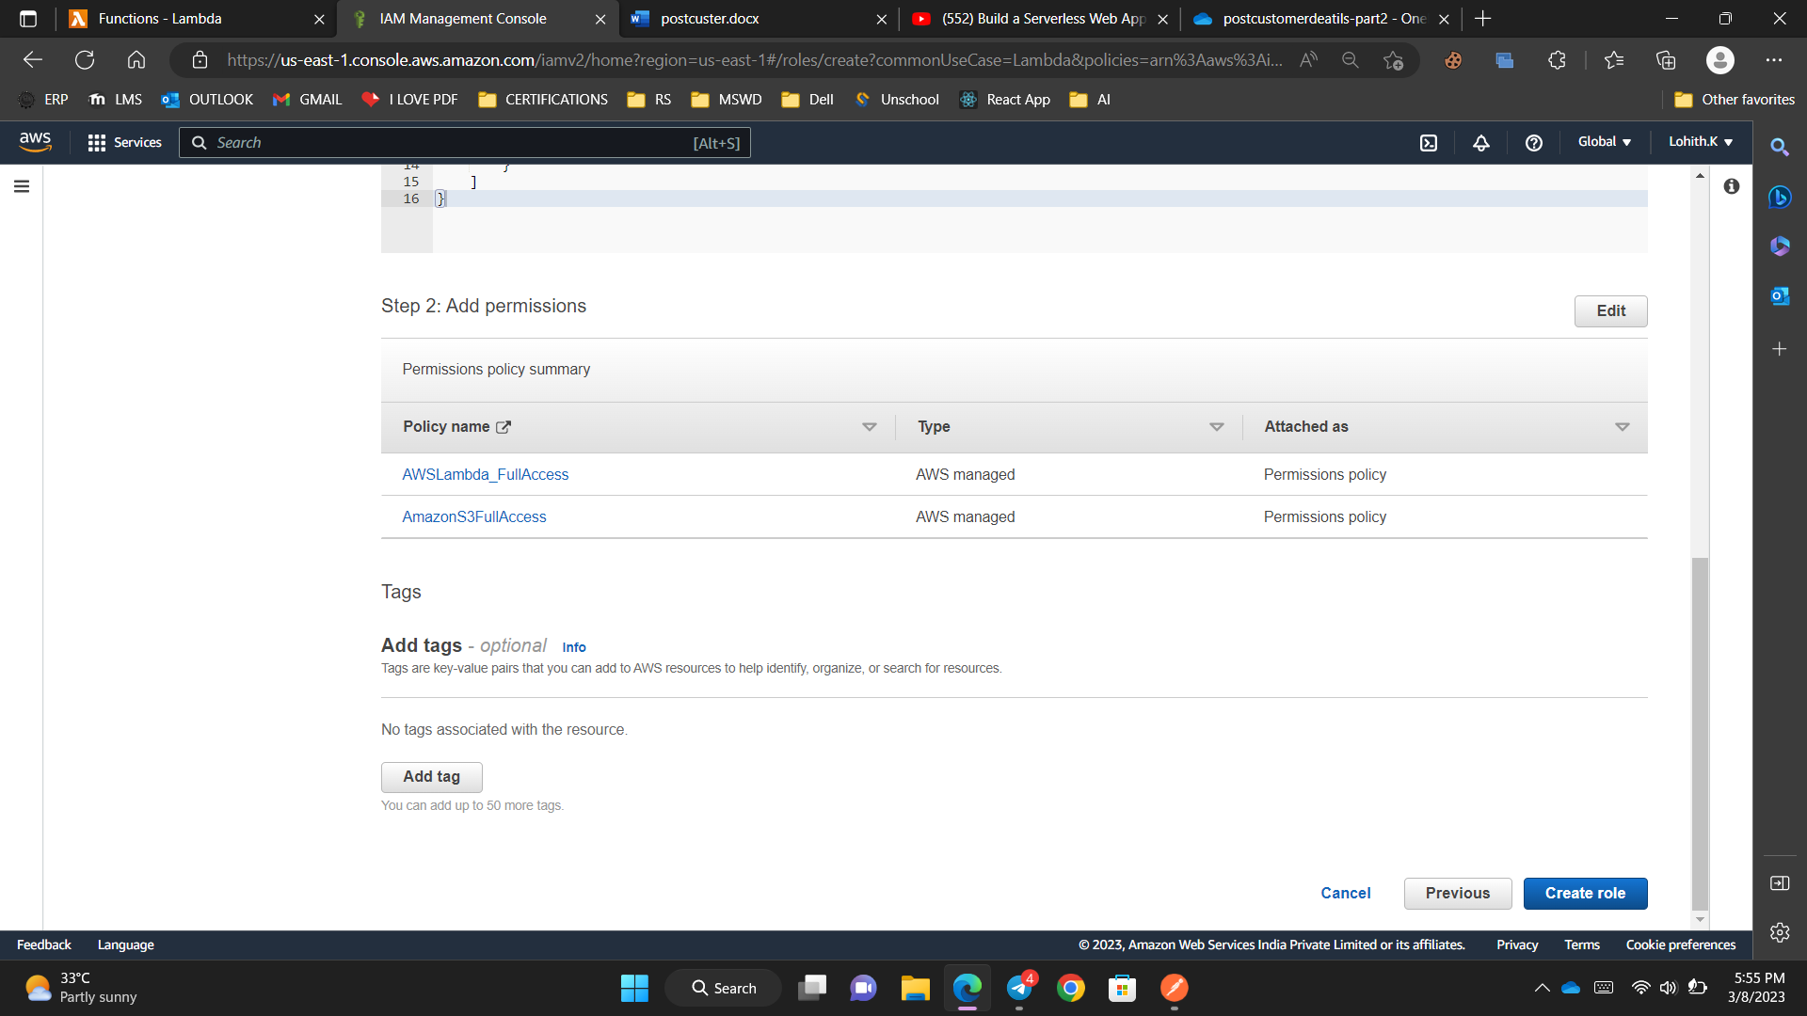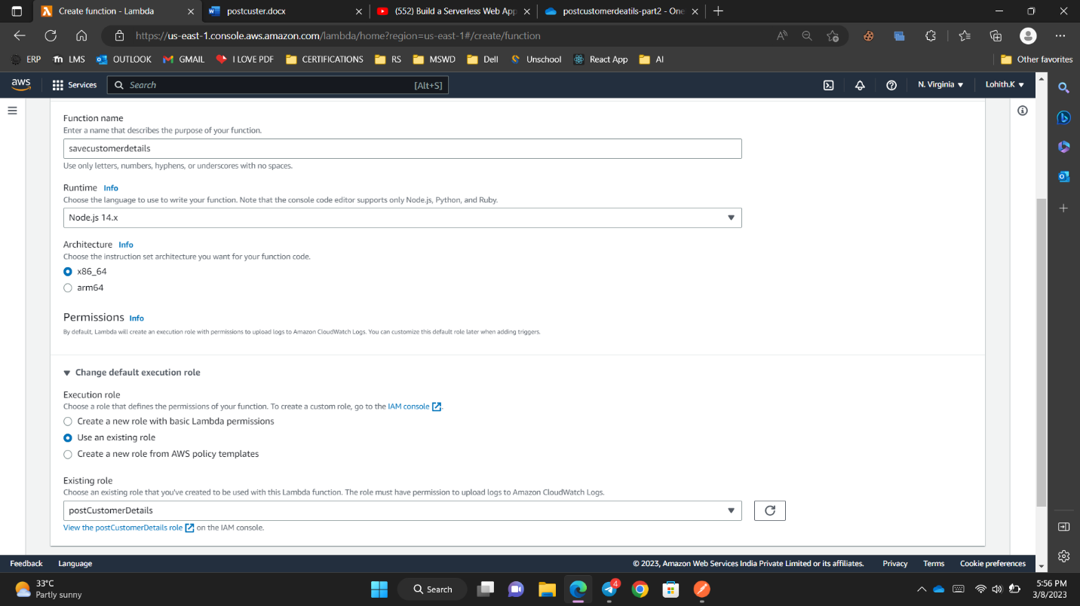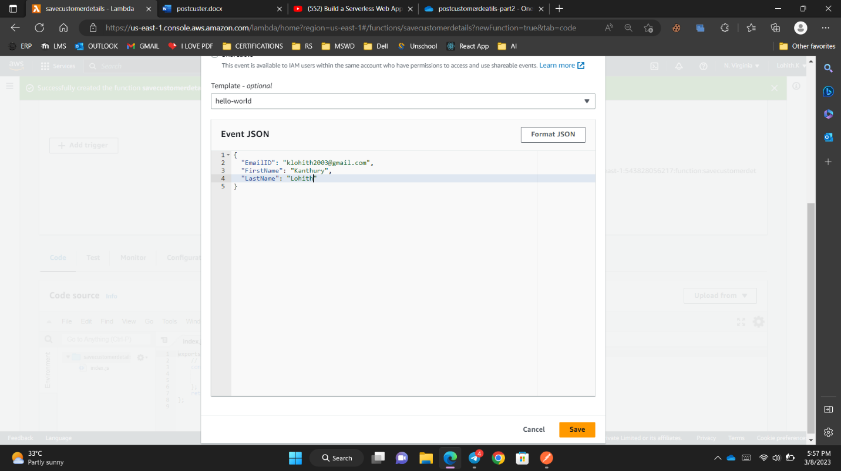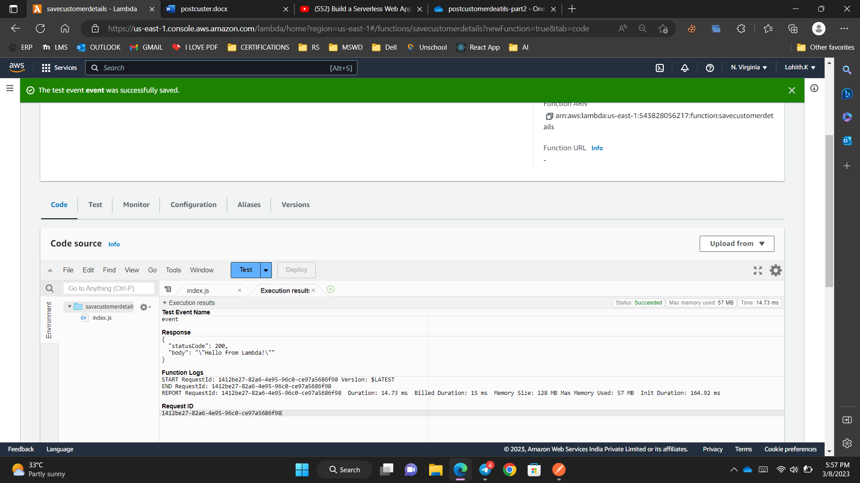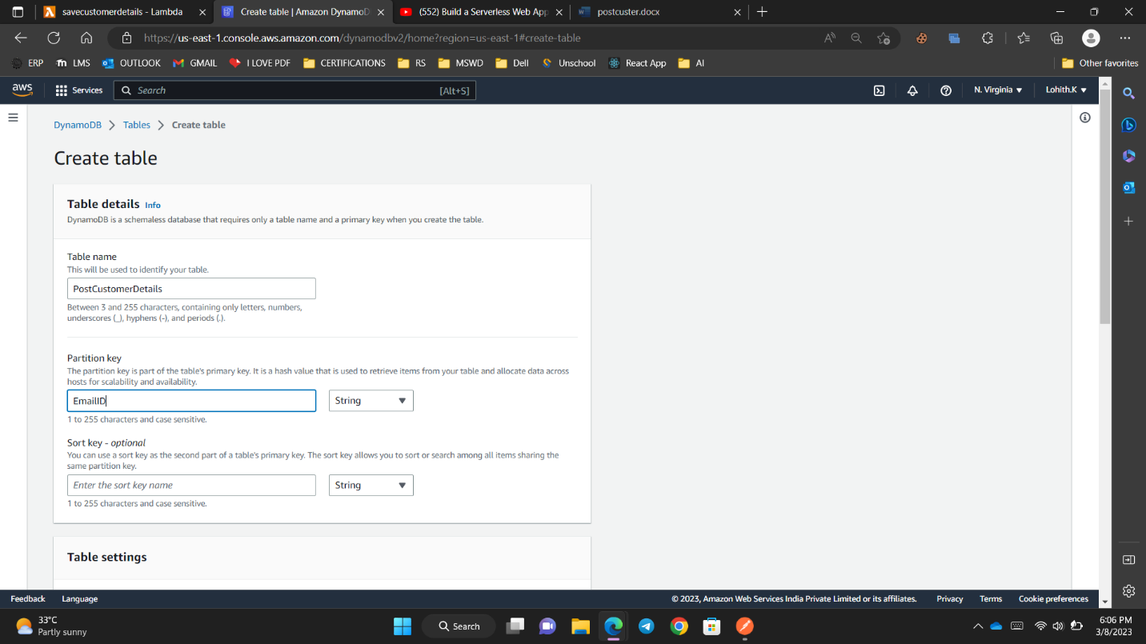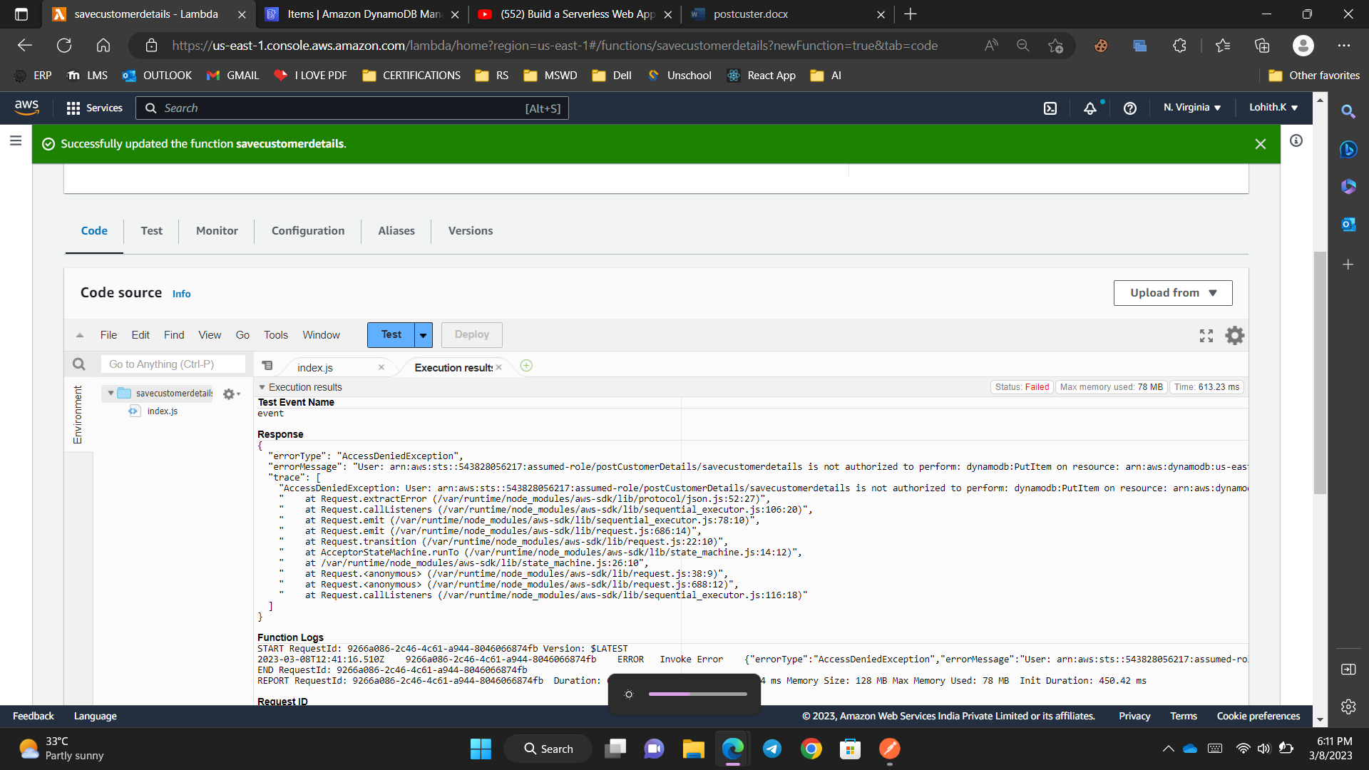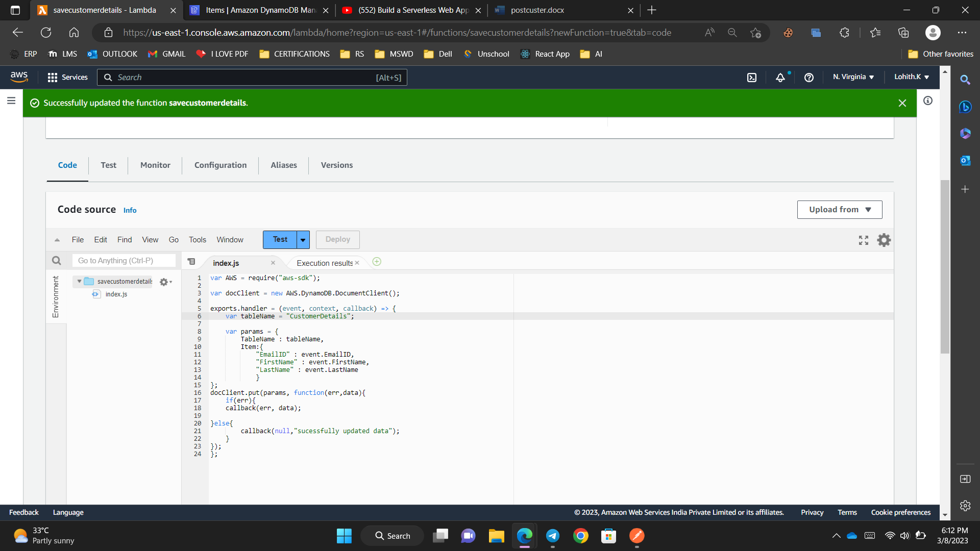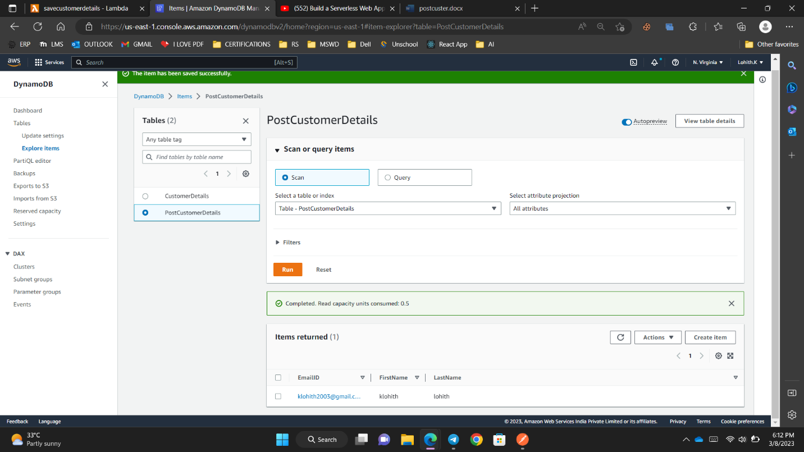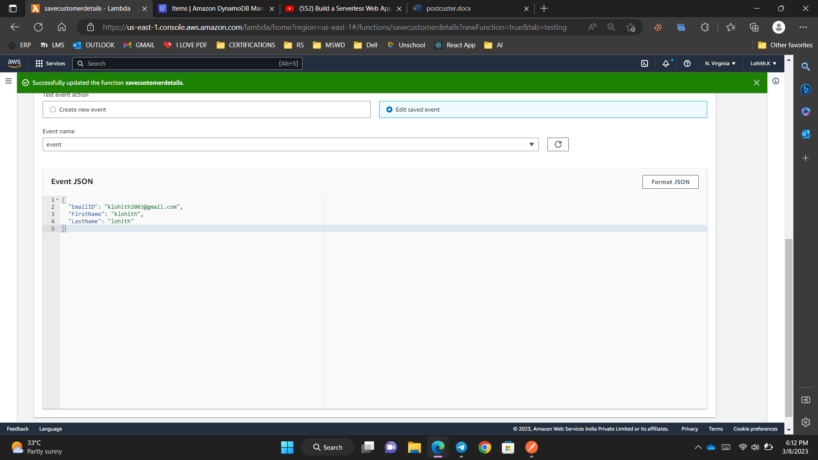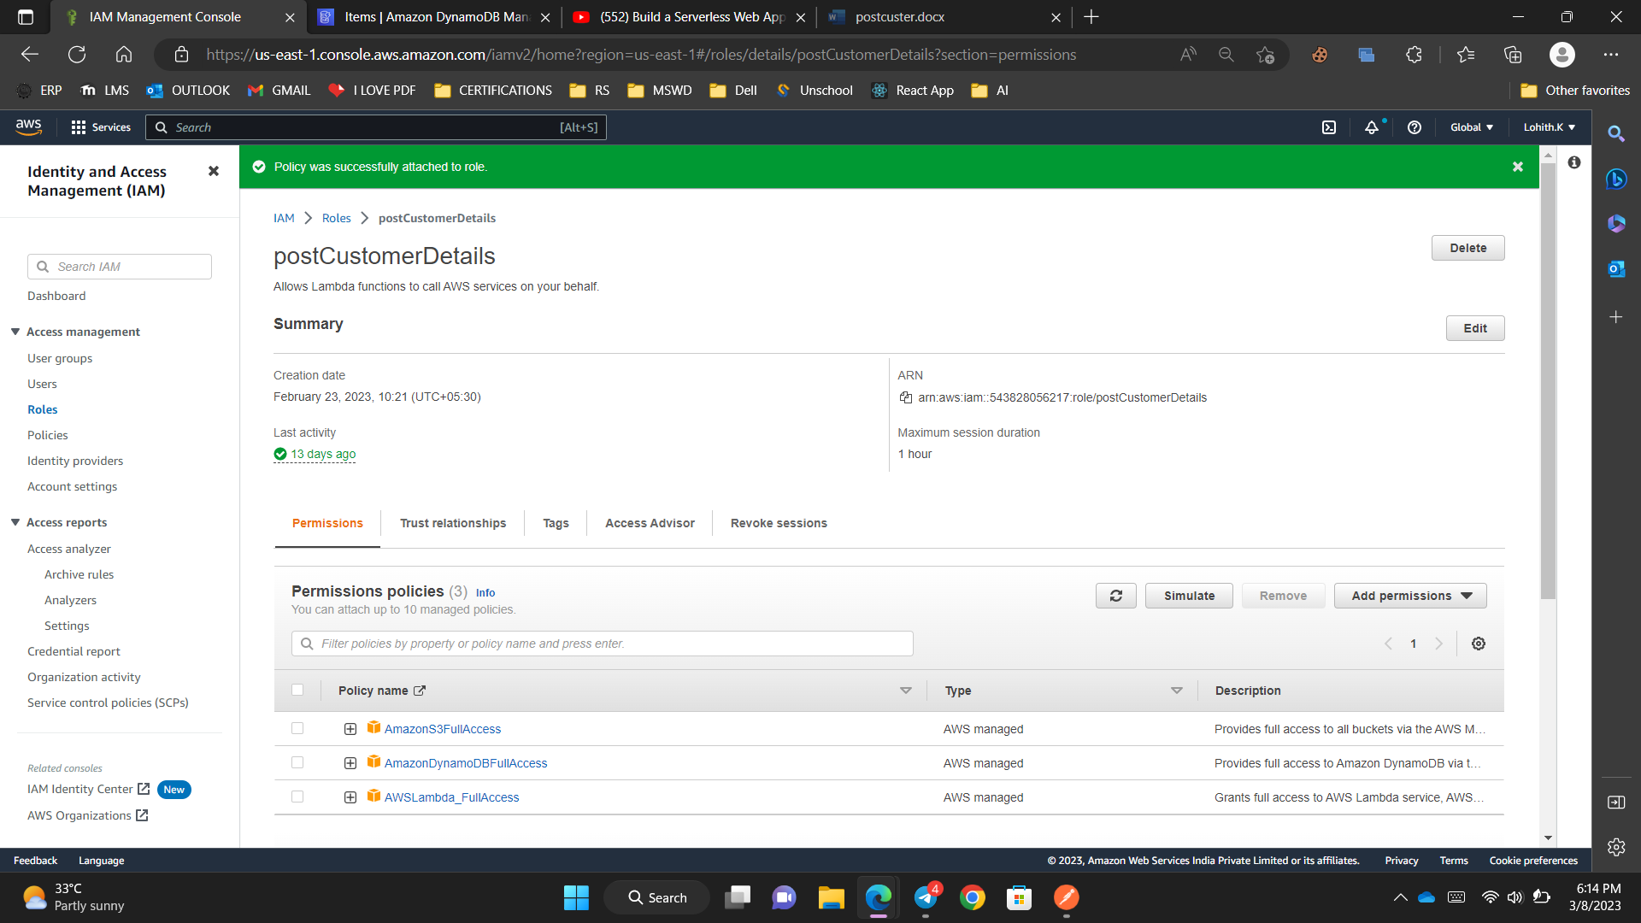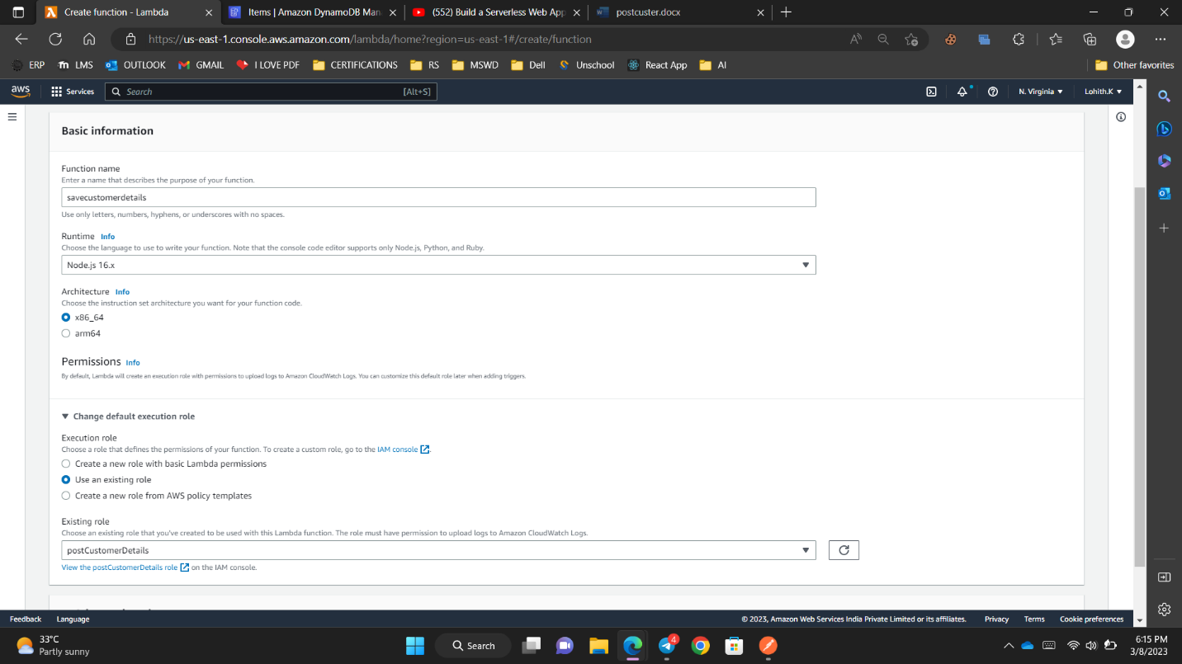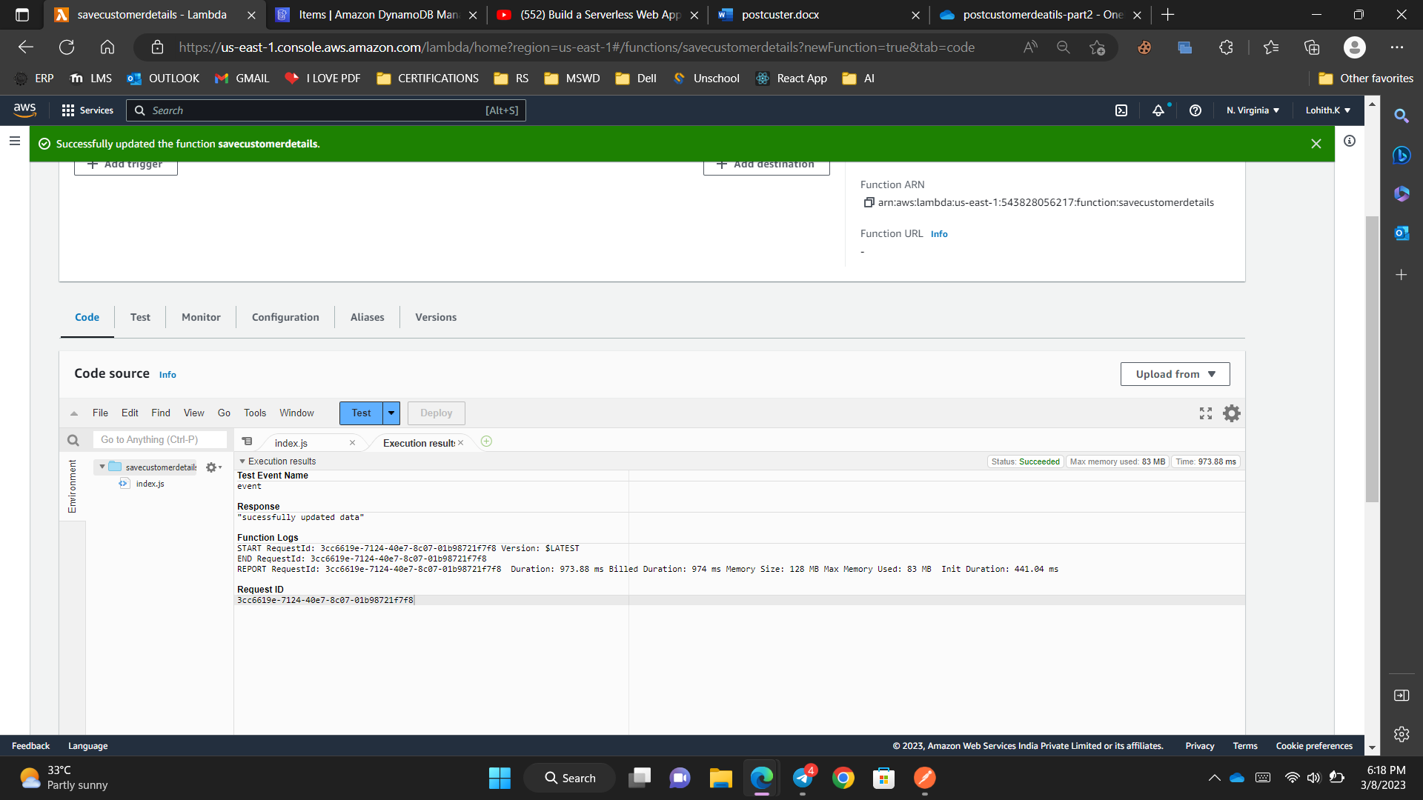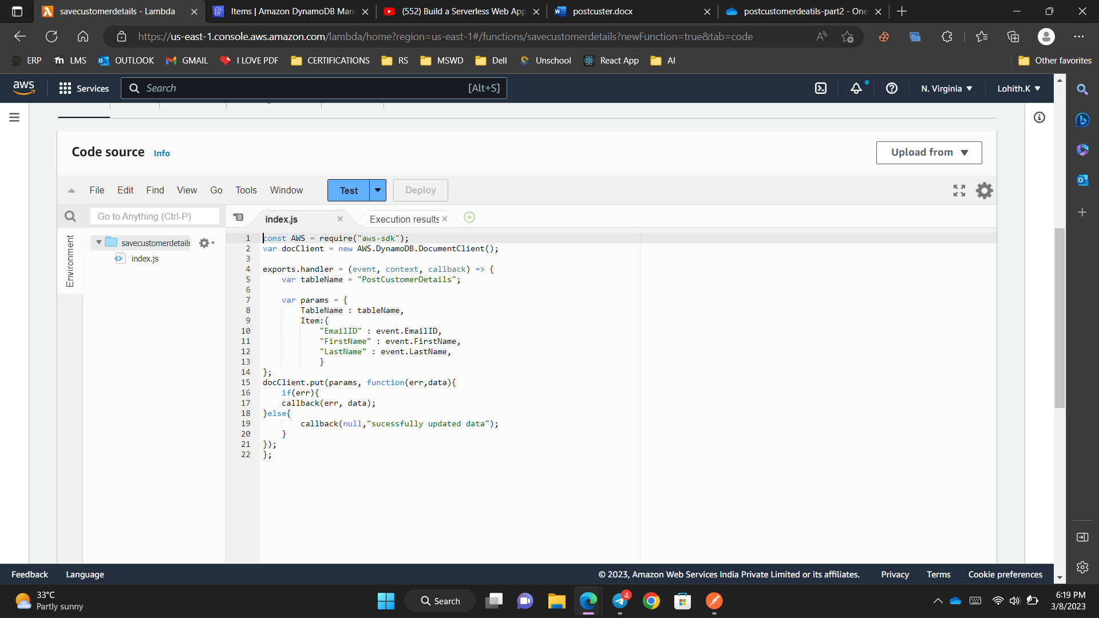

const AWS = require('aws-sdk');

var docClient = new AWS.DynamoDB.DocumentClient();

var tableName = "CustomerDetails";

exports.handler = (event, context, callback) => {

console.log(event.EmailID)

var params = {

TableName : tableName,

Key:{

"EmailID" : event.EmailID

}

}

docClient.get(params, function(err,data){

callback(err, data);

})

};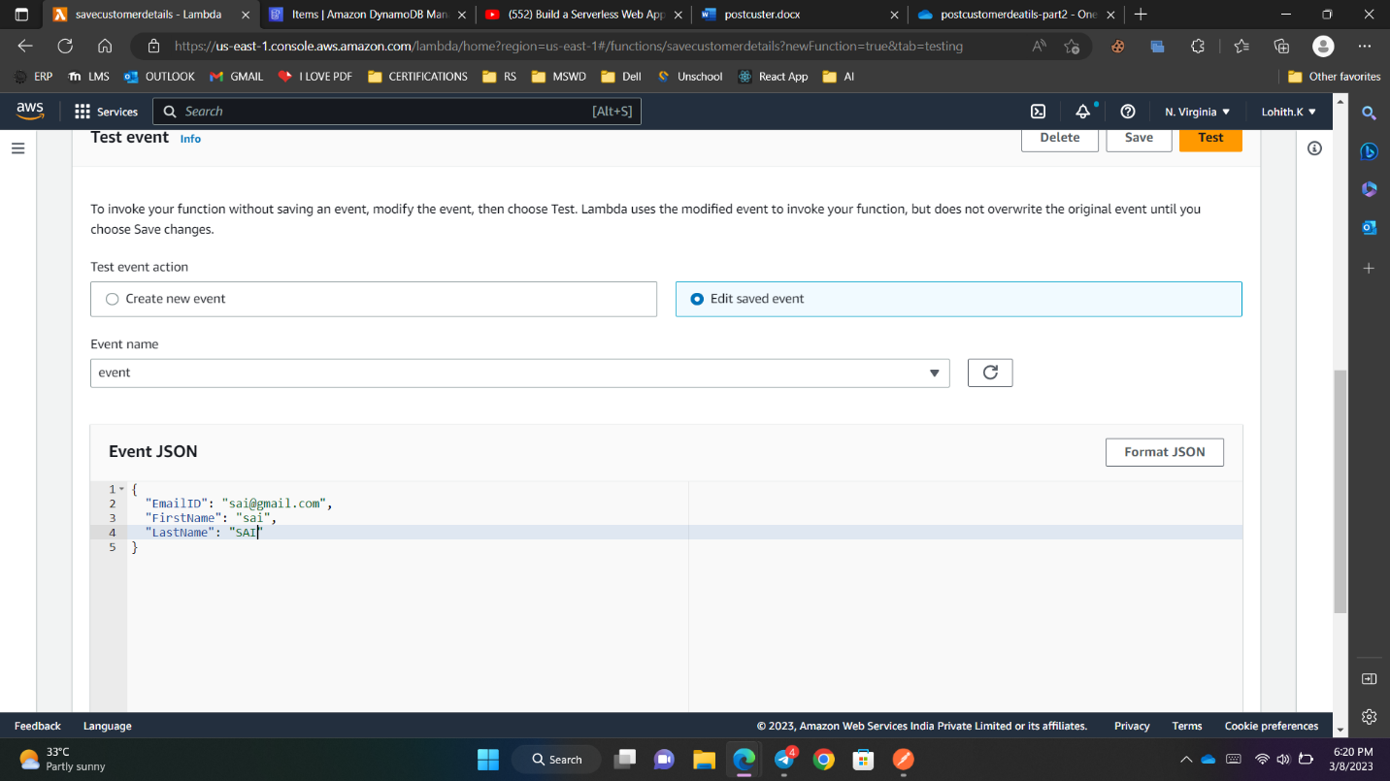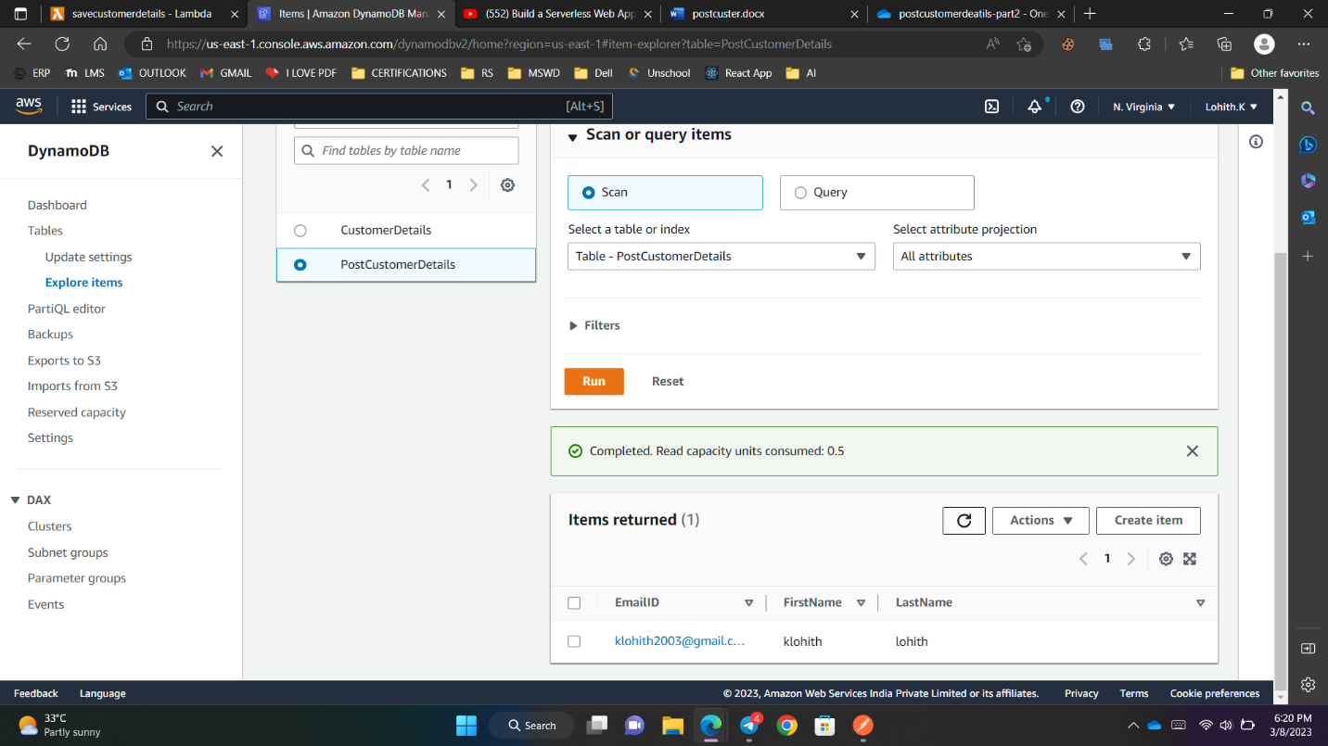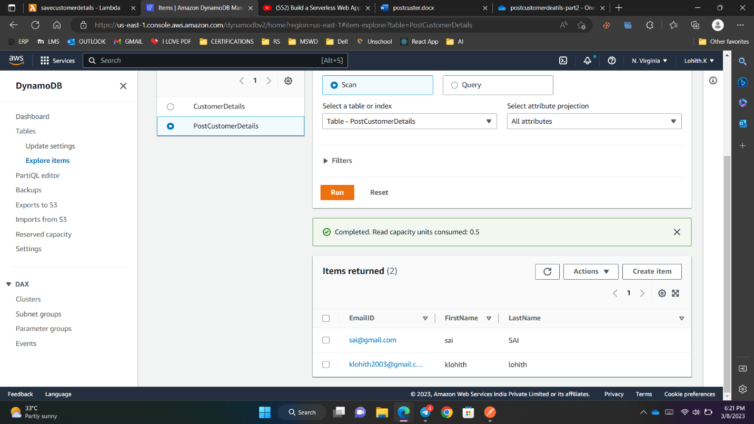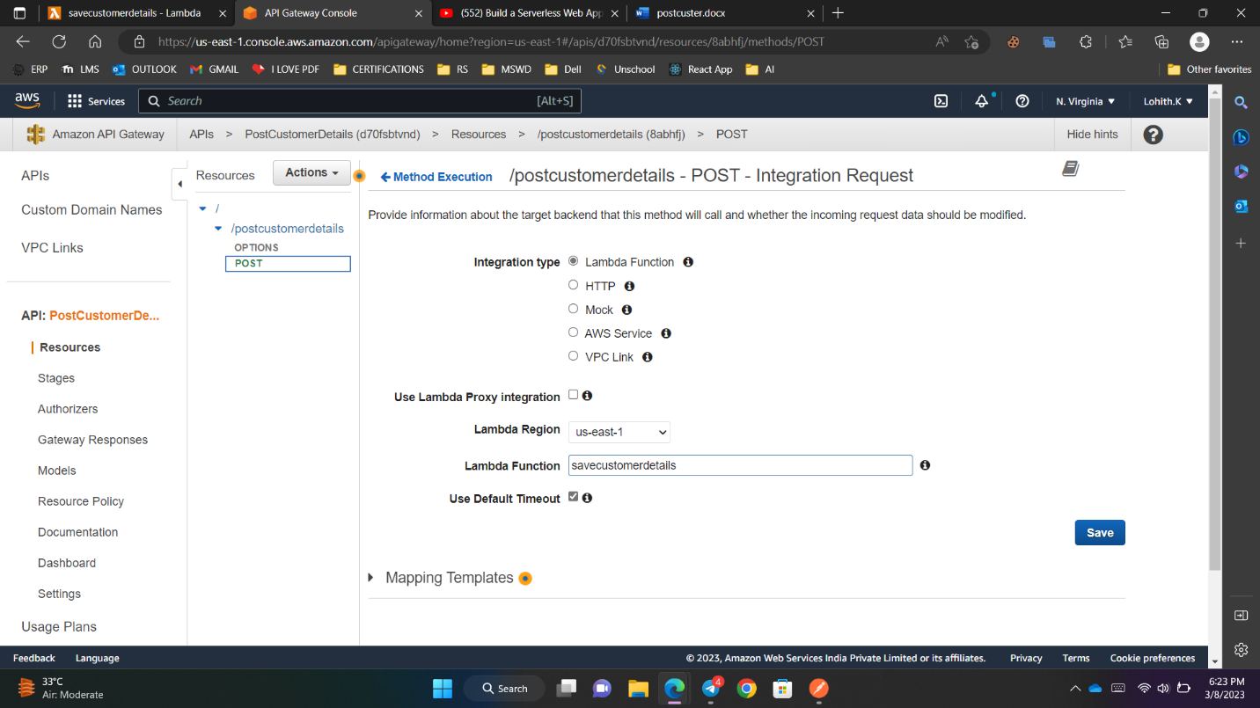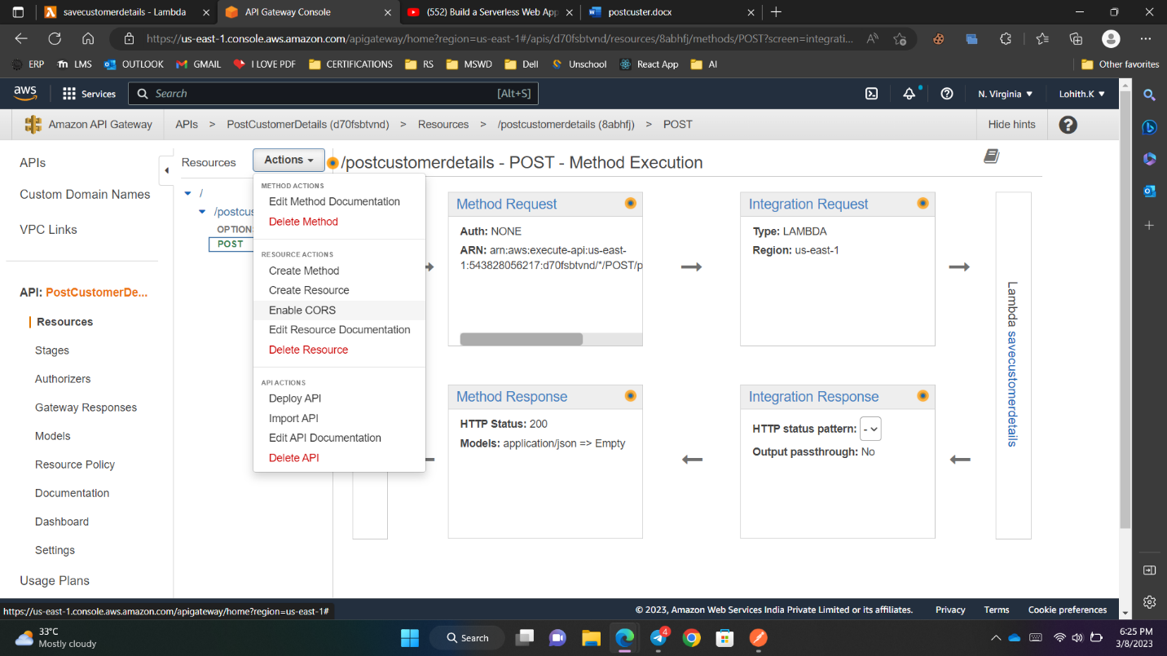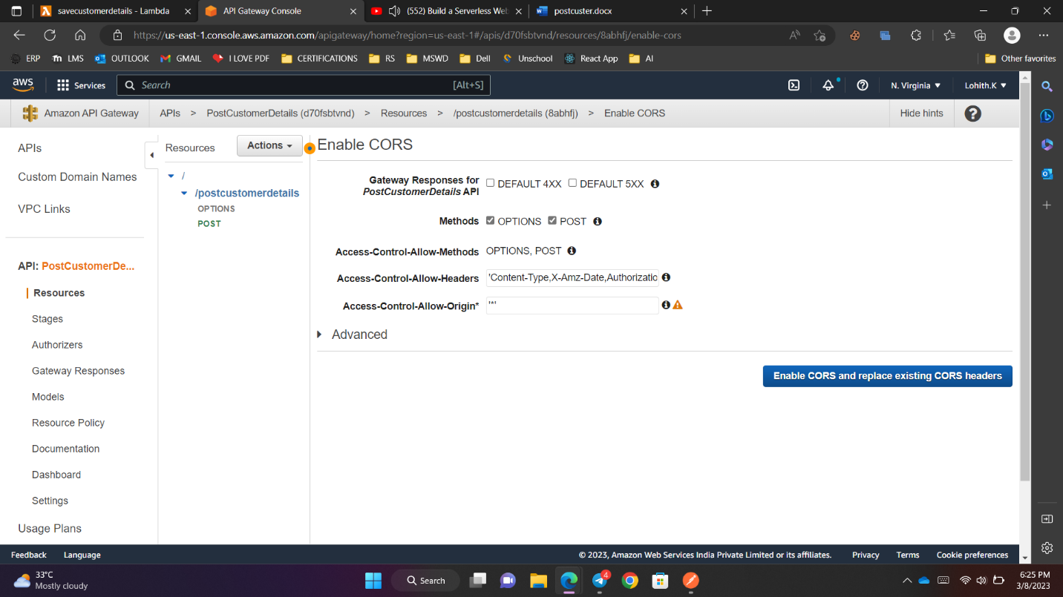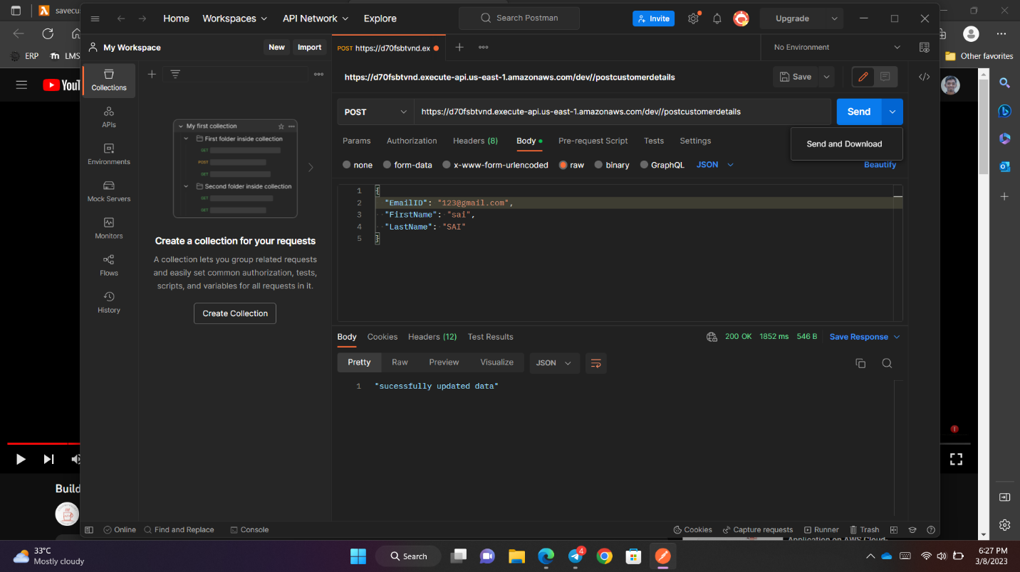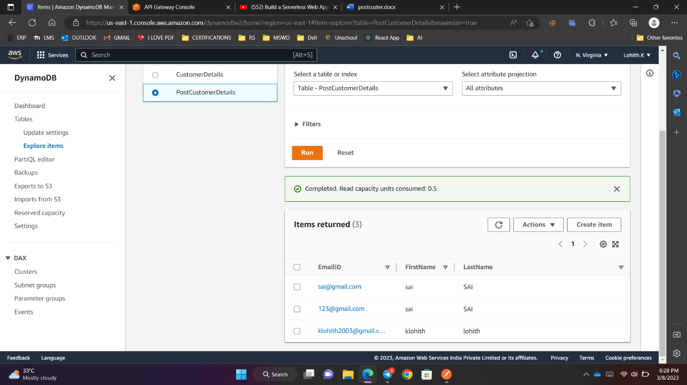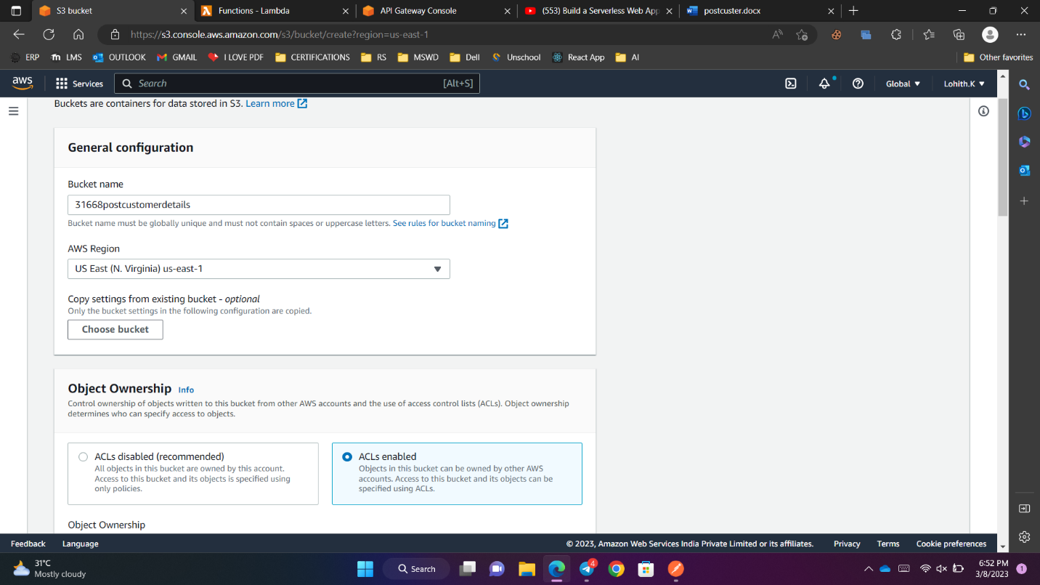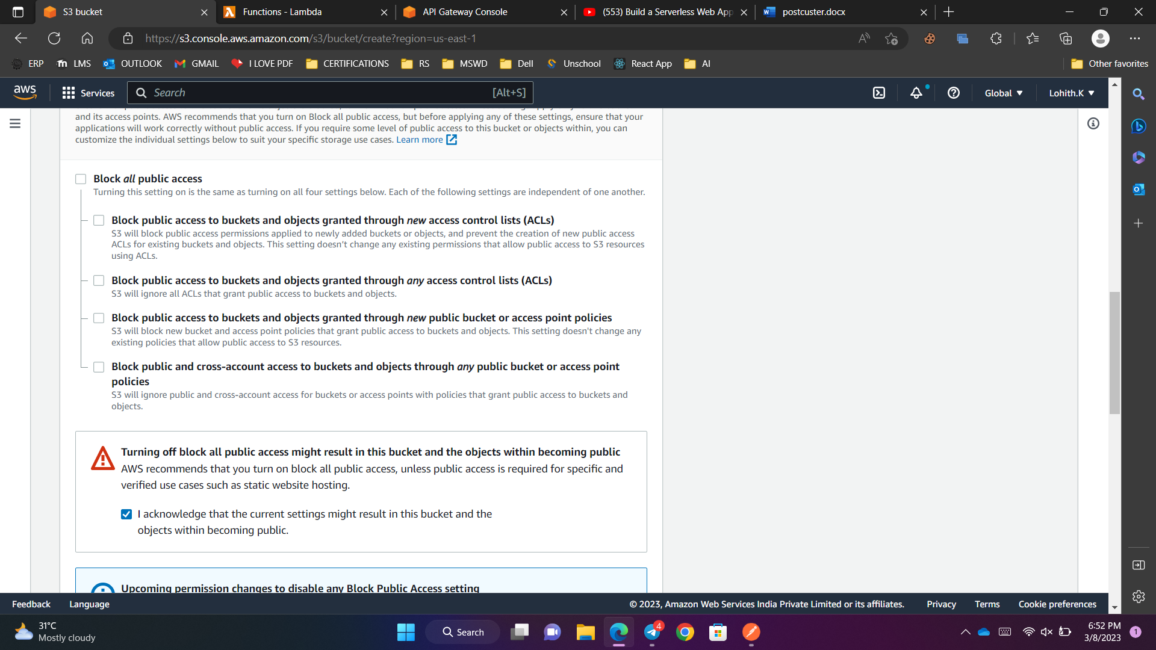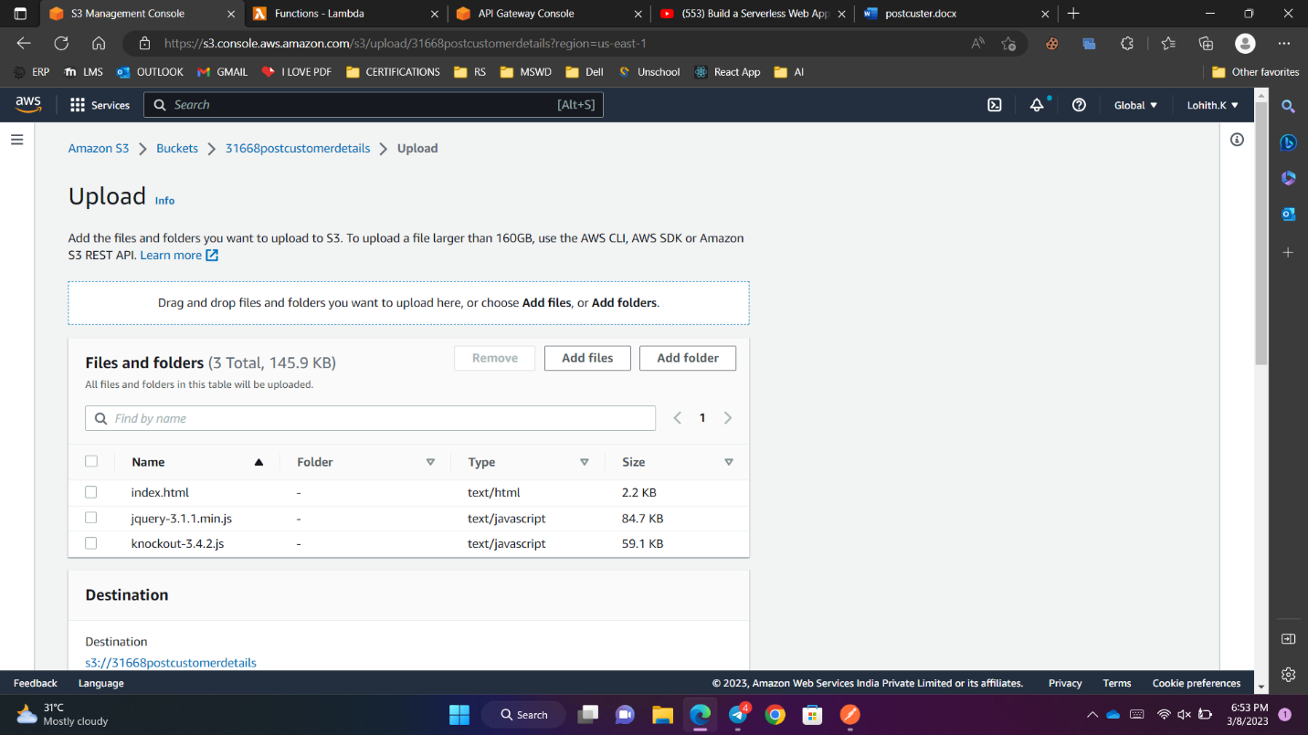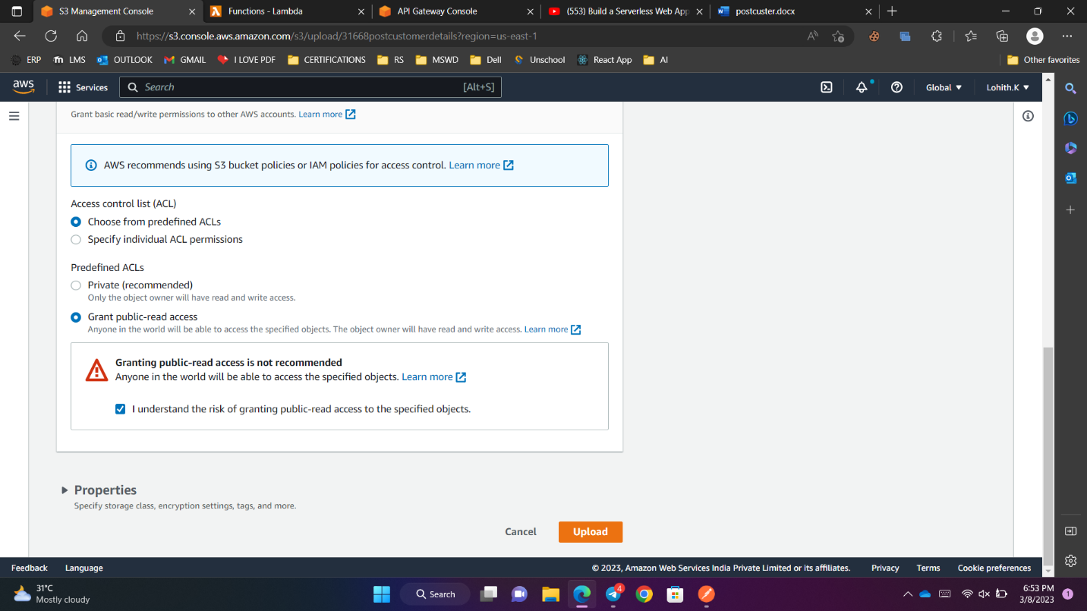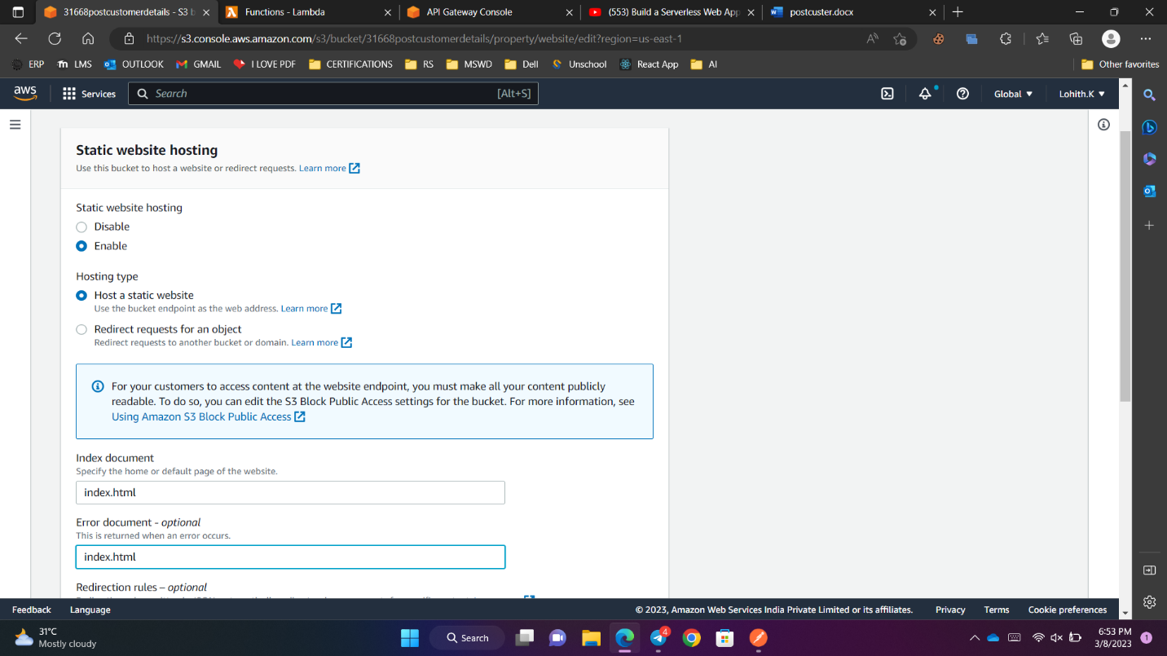

Index.html

<!DOCTYPE html>

<html>

<head>

<title></title>

<meta charset="utf-8" />

<script src="jquery-3.1.1.min.js"></script>

<script src="knockout-3.4.2.js"></script>

<script type="text/javascript">

jQuery.support.cors = true;

$(document).ready(function() {

var customerDetailsViewModel = function() {

var self = this;

self.EmailID = ko.observable("");

self.FirstName = ko.observable("");

self.LastName = ko.observable("");

self.SuccessMessage = ko.observable("");

self.savecustomerdetails = function () {

var CustomerDetail = {

EmailID: self.EmailID(),

FirstName: self.FirstName(),

LastName: self.LastName()

}

$.ajax({

crossDomain: true,

url: 'https://d70fsbtvnd.execute-api.us-east-1.amazonaws.com/dev/postcustomerdetails',

cache: false,

type: 'POST',

data: ko.toJSON(CustomerDetail),

success: function (data) {

self.SuccessMessage(data)

self.EmailID('');

self.FirstName('');

self.LastName('');

}

}).fail(

function(xhr, textStatus, err){

alert("Error happened "+err);

});

};

}

var viewModel = new customerDetailsViewModel();

ko.applyBindings(viewModel);

});

</script>

</head>

<body>

<table>

<tr>

<td>

<div>

<p>

EmailID:

<input data-bind='value: EmailID'/>

</p>

<p>

FirstName:

<input data-bind='value: FirstName' />

</p>

<p>

LastName:

<input data-bind='value: LastName' />

</p>

</div>

<span style ="color: darkolivegreen" data-bind='text : SuccessMessage' />

</td>

</tr>

<tr>

<td>

<div>

<button data-bind="click: $root.savecustomerdetails" > Save </button>

</div>

</td>

</tr>

</table>

</body>

</html>

